# Preparation

1. Set the simulation into Def Fast mode
2. Use a text editor to create and edit the code file, saving it locally each time, before loading it into the simulation to run. (This is safer than editing the code directly in the simulator).

# Story 1: Draw the starting snake and apple

## Requirement

Create a two-segment snake (head + tail) near the middle of the screen. The snake should be a green colour. Add an apple (a single pixel of a different colour) somewhere below the snake.

## Techniques

The simulation provides ‘addressable video memory’, that runs from (word) location 256 (0x100 in hex) for the top-left corner, to 1023 (0x3ff in hex) for the bottom-right.

Exercise

What does the following code produce?

mov r0,#0

str r0,256

str r0,1023

**[Peter: assembler does not accept direct addressing to the screen memory, I think it should]**

[Paste in a partial screenshot showing only the output window]

mov r0,#1, means ‘move into register 0, the immediate value 0’. This is known as ‘immediate address mode. In this case, the value 0 represents the colour black (no colour).

When the program starts register 0 should default to the value 0, but it is not safe to assume this, so we set it to 0 explicitly. This is equivalent to the practice of initialising all variables in a higher level language.

We can specify other colours using the same RGB (Red Green Blue) format as used when creating a web page. This is best specified in hex, so for example, 0x008844 results in a suitable hue of green for the snake.

## Implementation

Create and save a new file called Snake, and add the following code:

defineRegisters:

mov r12,#0x008844 //Snake colour (green)

drawSnake:

str r12,527 //Tail

str r12,528 //Head

Load the file into the simulator, assemble and run.

Paste in a partial screenshot showing the assembled code and the Output after running.

Notice that we have added three labels: defineRegisters:, drawSnake:, and drawApple:. These aren’t actually used by the program at this point, but they make the code more readable. [Paste in a partial screenshot showing the assembled code and the Output after running].

Why have we switched from using r0 to r12 for the green colour? We are simply adopting a common convention to use the lower-number registers for handling variable pieces of data and the higher-number ones for constants.

# Story 2: Move the snake

## Requirements

## Techniques

To move the snake one pixel to the right we *could* draw a new head in the next screen memory location (273) and then reset the tail (271) to the background colour (white), as shown below (*don’t modify your code yet):*

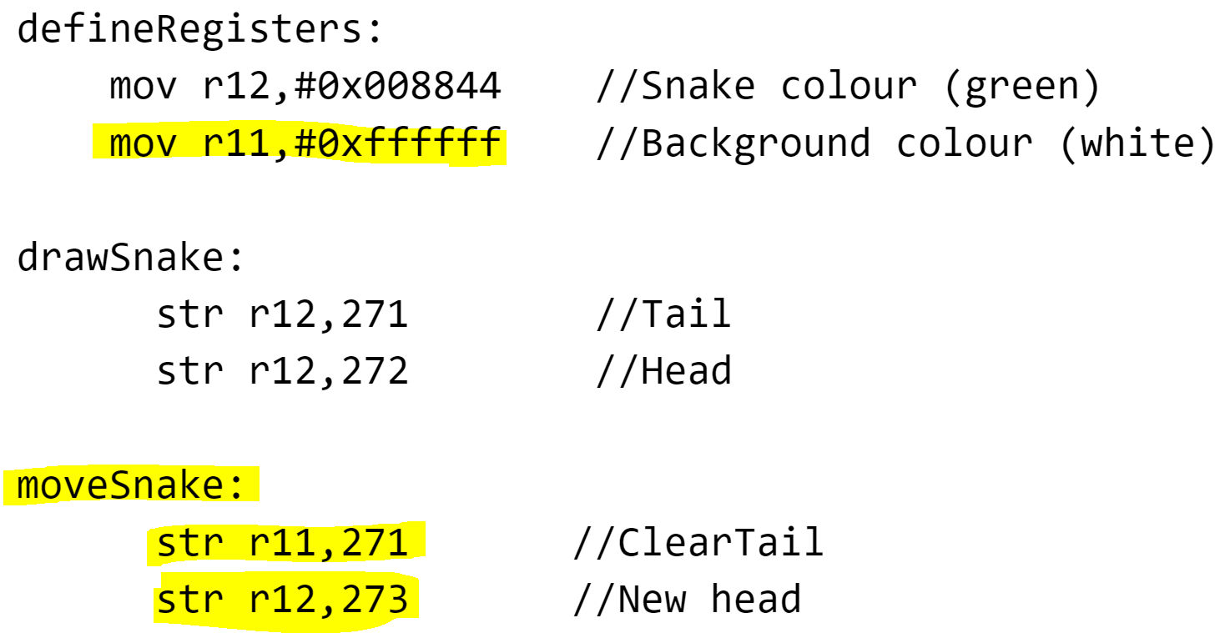

The problem with this approach is that it won’t *generalise*. We will have to add two new instructions for each pixel that the snake moves, and we won’t be able to vary it (eventually) based on live instructions from the player.

So we are going to *refactor* the code from story 1, making use of two more registers to hold the position of the head and tail:

mov r3, #271 //Head position, initialised  
 mov r4, #272 //Tail position, initialised

And then we are going to use these registers in the drawSnake routine, using *indirect addressing mode*, signalled by square brackets:

drawSnake:  
 str r12,[r4] //Tail  
 str r12,[r3] //Head

The first line can be read as ‘store the value held in r12 (the snake colour) into the memory address that is held in r4 (i.e. initially, memory location 272). *Indirection* lies at the heart of many advanced programming techniques.

Having done this, we can adjust the values held in r3 and r4 to point to new locations and then use the same store instructions to re-draw it. And if we do this in a loop then we can move the snake continuously to the right.

## Implementation

Modify your code to look like this.

defineRegisters:

mov r12,#0x008844 //Snake colour

mov r11,#0xffffff //Background colour (white)

mov r3, #528 //Head position, initialised

mov r4, #527 //Tail position, initialised

drawSnake:

str r12,[r4] //Tail

str r12,[r3] //Head

moveSnake:

str r11,[r4] //Reset tail to Background

add r4,r4,#1 //Increment the tail pointer

add r3,r3,#1 //Increment the head pointer

str r12,[r3] //Draw new head

b moveSnake //Loop

Modify your code from Story 1 (all new lines, and changes to existing lines, are highlighted).

Copy the code into the simulation, assemble, and run.

What happens when the snake gets to the right hand edge of the screen area, and why?

If you leave the program to run long enough you will get an error.

On which instruction number has the error occurred?

Which register is being used in that instruction, and what value is it holding at that time?

Why does this cause an error?

# Story 3: Add an apple, and allow the snake to eat it

## Requirements

At the start, draw an apple (one pixel of a different colour) in a position below the starting point of the snake such that the snake will pass over it. When this happens, the apple should disappear. (In a later story we will want to position the apple randomly.

## Implementation

We have already learned the patterns we need, so make the changes highlighted below.

defineRegisters:

mov r12,#0x008844 //Snake colour (green)

mov r11,#0xffffff //Background colour (white)

mov r10,#0xff8800 //Apple colour

mov r3, #528 //Head position, initialised

mov r4, #527 //Tail position, initialised

mov r5, #330 //Apple position

drawApple:

str r10,[r5]

drawSnake: (unchanged)

loop:

str r11,[r4+256] //Reset tail to Background

add r4,r4,#1 //Increment the tail pointer (for use next cycle)

moveHead:

add r3,r3,#1 //Increment the head pointer

str r12,[r3+256] //Draw new head

b loop

# Story 4: When the snake eats the apple, make it grow

## Techniques

We can detect the event of ‘eating’ the apple, by checking, within the loop, when the snake’s head position matches that of the apple. We can the grow the snake length by one, simply by not updating the position of the tail for that cycle of the loop.

## Implementation

defineRegisters: (unchanged)

drawApple: (unchanged)

drawSnake: (unchanged)

loop:

add r3,r3,#1 //Increment the head pointer

cmp r3,r5 //If the head is in same location as apple...

beq moveHead //...Skip updating the tail, to make snake grow

str r11,[r4+256] //Reset tail to Background

add r4,r4,#1 //Increment the tail pointer (for use next cycle)

moveHead:

str r12,[r3+256] //Draw new head

b loop

# Story 5: Refactor to use indexed addressing

We learned in Story 1 that screen memory runs from locations 256 to 1023. So far we have set the position of the snake, and the apple, *absolutely* e.g. using 528 as the starting position of the head, somewhere near the middle of the screen.

It would be more elegant, and make position-related calculations easier, if we could make all such positions *relative* to the start of screen memory. Thus, location 528 would be replaced by 272 (528 = 256 + 272). The assembler allows us to do this using *indexed* addressing mode, as shown below.

defineRegisters:

mov r12,#0x008844 //Snake colour (green)

mov r11,#0xffffff //Background colour (white)

mov r10,#0xff8800 //Apple colour

mov r3, #272 //Head position, initialised

mov r4, #271 //Tail position, initialised

mov r5, #330 //Apple position

drawApple:

str r10, [r5+256]

drawSnake:

str r12,[r4+256] //Tail

str r12,[r3+256] //Head

loop:

add r3,r3,#1 //Increment the head pointer

cmp r3,r5 //If the head is in same location as apple...

beq moveHead //...Skip updating the tail, to make snake grow

moveTail:

str r11,[r4+256] //Reset tail to Background

add r4,r4,#1 //Increment the tail pointer (for use next cycle)

moveHead:

str r12,[r3+256] //Draw new head

b loop

Each of the changed versions above can be read as ‘calculate the address based on 256 plus the value held in the register’. In each case the *base* address is fixed at 256 and the *index* (added to that base address) is provided by the specified register (r3, r4, or r5 in different contexts).

# Story 6: Change of direction

## Requirements

When the S key is pressed, switch to moving downwards. This will continue until the head reaches the bottom of the screen.

## Techniques

The following code looks like it should work, but it actually contains a subtle bug.

OUT OF DATE - REDO

defineRegisters: (unchanged)

drawApple: (unchanged)

drawSnake: (unchanged)

loop:

inp r0,4

cmp r0,#83 //S key

beq down

right:

mov r1,#1 //Set r1 with to be an increment of 1

b draw

down:

mov r1,#32 //32 moves down one row on screen

draw:

add r3,r3,r1 //Instead of adding a constant increment, add r1

str r12,[r3] //Draw new head

cmp r3,r5 //If the head is in same location as apple...

beq endOfLoop //...Skip updating the tail, to make snake grow

str r11,[r4] //Reset tail to Background

add r4,r4,r1 //Add r1 to r4, as we did for r3 also

endOfLoop:

b loop

**What happens when you run the game and hit the ‘s’ key to change direction, downwards?**

**Try stepping through the program, hitting the ‘s’ key early to see if you can see what the bug is?**

# Story 6b: Refactor to hold snake’s path in data

The bug is quite subtle. Upon the change in direction we immediately start moving both the head and the tail pointers (r3 and r4) downwards. But because the tail is (initially) one to the left of the head, they are going to move down next to each other, not in the same column of pixels, so the new trail created by the advancing head, is never reset to the background colour by the advancing tail. And if you change direction after the snake has eaten the apple and grown to three segments, the head and tail will move downwards further apart.

[add diagram]

To fix this properly, and, especially, to cope with later versions of the game where the snake may acquire a complex shape from many turns, we really need to ensure that the tail always follows the same path as the head, lagging behind by as many segments as the snake is long.

Could this be done by getting the tail-update routine to read the screen memory, looking to see in which direction is the next snake-coloured pixel. That might work for simple cases, but won’t work if the snake has doubled-back on itself e.g.

[add diagram]

The proper solution is to keep a record of locations the head has passed through, elsewhere in memory. We can declare this with a label and the pseudo-instruction DAT, at the end of our code. We should change our initial drawSnake routine to copy the locations into this data area as well as setting the screen:

defineRegisters:

mov r12,#0x008844 //Snake colour (green)

mov r11,#0xffffff //Background colour (white)

mov r10,#0xff8800 //Apple colour

mov r5, #330

mov r4, #body //Pointer to tail address in body data

add r3,r4,#1 //Pointer to head address in body data (1 after tail)

mov r2, #271 //Initial position for tail

mov r1, #272 //Initial position for head

InitialisePointers:

str r2, [r4] //r4 points to the tail address

str r1, [r3] //r3 points to the head address

drawSnake:

str r12, [r2+256] //Draw tail on screen

str r12, [r1+256] //Draw head on screen

drawApple:

str r10, [r5+256]

loop:

add r1,r1,#1 //Increment the head location

cmp r1,r5 //If the head is in same location as apple...

beq moveHead //...Skip updating the tail, to make snake grow

moveTail:

ldr r2, [r4]

str r11,[r2+256] //Reset tail to Background

add r4,r4,#1 //Increment the tail pointer (for use next cycle)

moveHead:

add r3,r3,#1 //Increment the head pointer

str r1, [r3] //Store the new head location in data

str r12,[r1+256] //Draw new head

b loop

body: dat 0 //body segment pointers extend from here to end of memory (addr 199)

# Story 6c: When data area if full, loop the pointers around to the start

## Techniques

Implement this like a circular queue that uses an array with two pointers (except that here we only ever add to the queue).

(no changes before the loop label)

loop:

add r1,r1,#1 //Increment the head location

cmp r1,r5 //If the head is in same location as apple...

beq moveHead //...Skip updating the tail, to make snake grow

moveTail:

ldr r2, [r4]

str r11,[r2+256] //Reset tail to Background

add r4,r4,#1 //Increment the tail pointer (for use next cycle)

cmp r4,#200

blt moveHead

mov r4, #body //Loop pointer back to start of body data

moveHead:

add r3,r3,#1 //Increment the head pointer

cmp r3,#200

blt updatePointer //Loop pointer back to start of body data

mov r3, #body

updatePointer:

str r1, [r3] //Store the new head location in data

str r12,[r1+256] //Draw new head

b loop

body: dat 0 //body segment pointers extend from here to end of memory (addr 199)